**Computer Vision**

**Course Code: MEAD-652**

**Lab Practical File**

**Submitted by**

**Shantanu Shukla**

**01211805424**

**in partial fulfillment for the award of the degree**

**of**

**Master of Technology (AI & DS)**

**batch of 2024 - 26 (2nd Semester)**



**Center for Development of Advanced Computing, Noida**

**Affiliated to Guru Gobind Singh Indraprastha University**

|  |  |  |  |  |
| --- | --- | --- | --- | --- |
| 1. **No** | **Title** | **Page No.** | **Date** | **Signature** |
| 1 | **Exercise-1:**   1. Matrix operations using NumPy 2. Basic image manipulations 3. Singular Value Decomposition | 3-8 | 27-01-2025 |  |
| 2 | **Exercise-2:** Sobel Edge Detection | 9 | 03-02-2025 |  |
| 3 | **Exercise-3:** Harris Corner Detection | 10 | 10-02-2025 |  |
| 4 | **Exercise-4:** 2D - Transformations on an image:   1. Shear 2. Scale 3. Transition 4. Rotation 5. Affine | 11-13 | 17-02-2025 |  |
| 5 | **Exercise-5:** Box Filter | 14 | 03-03-2025 |  |
| 6 | **Exercise-6:** Shadow Effect | 15-16 | 10-03-2025 |  |
| 7 | **Exercise-7:** Gaussian Filtering | 17 | 17-03-2025 |  |
| 8 | **Exercise-8:** Laplacian Filtering | 18 | 24-03-2025 |  |
| 9 | **Exercise-9:** Gaussian Pyramid | 19 | 07-04-2025 |  |
| 10 | **Exercise-10:** Image Classification using CNN | 20-33 | 21-04-2025 |  |

**Exercise-1**

1. **Matrix Operations using Numpy:**

**Code:**

1. import numpy as np

2.

3. M = np.array(

4. [

5. [1, 2, 3],

6. [4, 5, 6],

7. [7, 8, 9],

8. [0, 2, 2],

9. ]

10. )

11.

12. a = np.array(

13. [

14. [1],

15. [1],

16. [0],

17. ]

18. )

19.

20. b = np.array(

21. [

22. [-1],

23. [2],

24. [5],

25. ]

26. )

27.

28. c = np.array(

29. [

30. [0],

31. [2],

32. [3],

33. [2],

34. ]

35. )

36.

37.

38.

39. print(np.dot(a.T, b))

40. print(np.multiply(a, b).T)

41. print(np.multiply(a, b).T)

42. print(M * a.T)

43. print(np.sort(M))

**Output:**

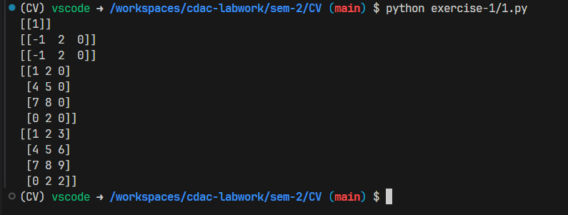

1. **Basic Image Manipulations:**

**Code:**

1. import numpy as np

2. import matplotlib.pyplot as plt

3. import skimage as sk

4.

5. imageA = sk.io.imread('./image1.jpg')

6. imageB = sk.io.imread('./image2.jpg')

7.

8. plt.figure()

9. plt.title('Image A')

10. plt.xlabel('width')

11. plt.ylabel('height')

12. plt.imshow(imageA)

13.

14. plt.figure()

15. plt.title('Image B')

16. plt.xlabel('width')

17. plt.ylabel('height')

18. plt.imshow(imageB)

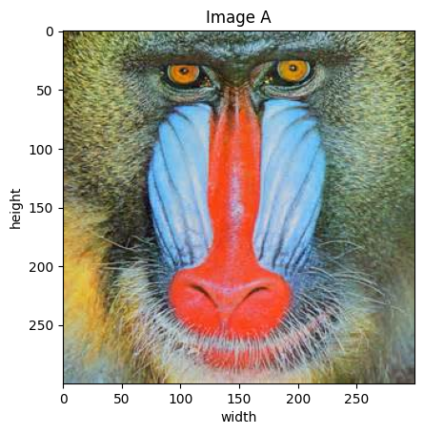 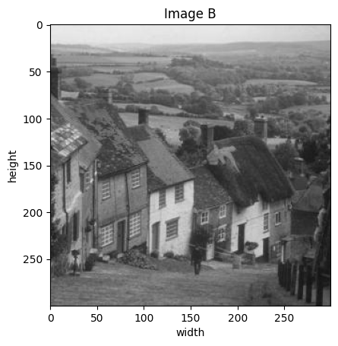

1. # Convert the images to double precision

2. imageA = imageA.astype(np.float64)

3. imageB = imageB.astype(np.float64)

4.

5. # rescale them to stretch from minimum value 0 to maximum value 1

6. imageA = (imageA - np.min(imageA)) / (np.max(imageA) - np.min(imageA))

7. imageB = (imageB - np.min(imageB)) / (np.max(imageB) - np.min(imageB))

8.

9. merged_image = imageA + imageB

10. merged_image = (merged_image - np.min(merged_image)) / (np.max(merged_image) - np.min(merged_image))

11.

12. # set size of the result image

13. merged_image = (merged_image * 255).astype(np.uint8)

14.

15. # print merged image

16. plt.figure()

17. plt.title('Merged Image')

18. plt.xlabel('width')

19. plt.ylabel('height')

20. plt.imshow(merged_image)

21.

22. # save merged image

23. sk.io.imsave('./merged.jpg', merged_image)

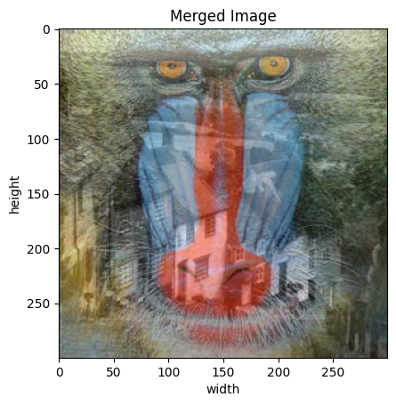

1. height, width, channels = imageA.shape

2. combined_image = np.zeros_like(imageA)

3.

4. combined_image[:, :width//2, :] = imageA[:, :width//2, :]

5. combined_image[:, width//2:, :] = imageB[:, width//2:, :]

6.

7. # print combined image

8. plt.figure()

9. plt.title('Combined Image')

10. plt.xlabel('width')

11. plt.ylabel('height')

12. plt.imshow(combined_image)

13.

14. # set size of the result image

15. combined_image = (combined_image * 255).astype(np.uint8)

16.

17. # save combined image

18. sk.io.imsave('./combined.jpg', combined_image)

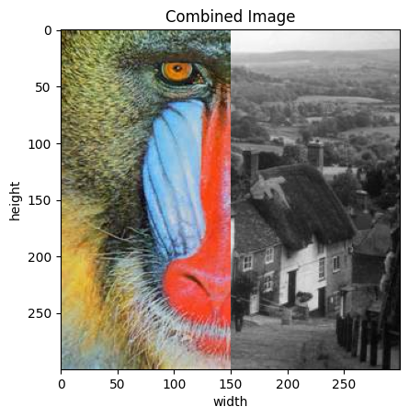

1. alternating_image = np.zeros_like(imageA)

2. for i in range(height):

3. if i % 2 == 0:

4. alternating_image[i, :, :] = imageA[i, :, :]

5. else:

6. alternating_image[i, :, :] = imageB[i, :, :]

7.

8. # set size of the result image

9. alternating_image = (alternating_image * 255).astype(np.uint8)

10.

11. # print alternating image

12. plt.figure()

13. plt.title('Alternating Image')

14. plt.xlabel('width')

15. plt.ylabel('height')

16. plt.imshow(alternating_image)

17.

18. sk.io.imsave('alternating_image.jpg', alternating_image)

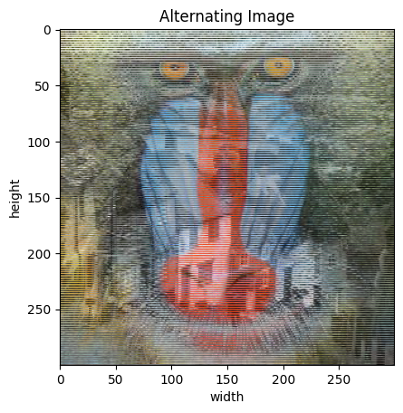

1. rows_imageA = imageA[::2, :, :]

2. rows_imageB = imageB[1::2, :, :]

3.

4. alternating_image_without_loop = np.zeros_like(imageA)

5. alternating_image_without_loop[::2, :, :] = rows_imageA

6. alternating_image_without_loop[1::2, :, :] = rows_imageB

1. # print alternating image

2. plt.figure()

3. plt.title('Alternating Image Without Loop')

4. plt.xlabel('width')

5. plt.ylabel('height')

6. plt.imshow(alternating_image_without_loop)

7.

8. # set size of the result image

9. alternating_image_without_loop = (alternating_image_without_loop * 255).astype(np.uint8)

10. sk.io.imsave('alternating_image_without_loop.jpg', alternating_image_without_loop)

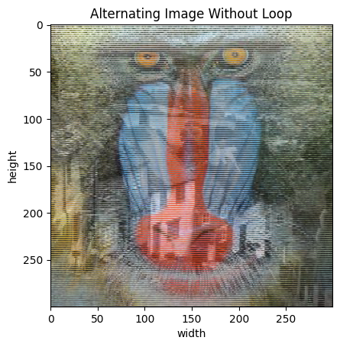

1. grayscale_image = sk.color.rgb2gray(alternating_image_without_loop)

2.

3. # set size of the result image

4. grayscale_image = (grayscale_image * 255).astype(np.uint8)

5.

6. # print grayscale image

7. plt.figure()

8. plt.title('Grayscale Image')

9. plt.xlabel('width')

10. plt.ylabel('height')

11. plt.imshow(grayscale_image, cmap='gray')

12. sk.io.imsave('grayscale_image.png', grayscale_image)

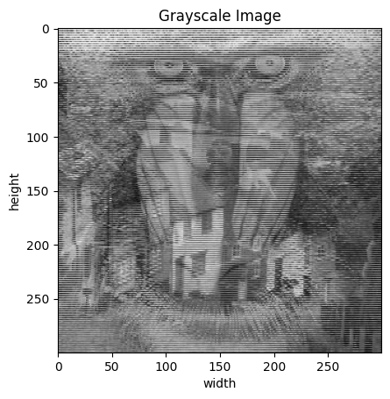

1. **Singular Value Decomposition**

1. import numpy as np

2. import matplotlib.pyplot as plt

3. from skimage import io

4.

5. imageA_grey = io.imread('./image1.jpg', as_gray=True)

6.

7. U, S, Vt = np.linalg.svd(imageA_grey, full_matrices=False)

8. rank = 1

9. rank_1_approx = U[:, :rank] @ np.diag(S[:rank]) @ Vt[:rank, :]

10.

11. # Save and display the rank-1 approximation

12. plt.imshow(rank_1_approx, cmap='gray')

13. plt.title(f'Rank-{rank} Approximation')

14. plt.axis('off')

15. plt.savefig('rank_1_approx.jpg', bbox_inches='tight', pad_inches=0)

16. plt.show()

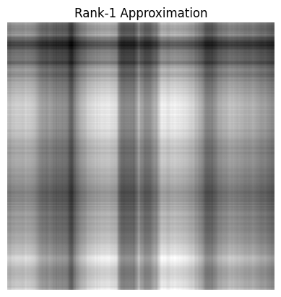

1. rank = 20

2. rank_20_approx = U[:, :rank] @ np.diag(S[:rank]) @ Vt[:rank, :]

3.

4. # Save and display the rank-20 approximation

5. plt.imshow(rank_20_approx, cmap='gray')

6. plt.title(f'Rank-{rank} Approximation')

7. plt.axis('off')

8. plt.savefig('rank_20_approx.png', bbox_inches='tight', pad_inches=0)

9. plt.show()

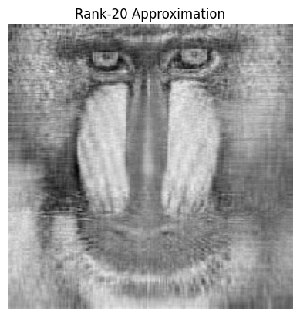

**Exercise-2**

**Objective:** Sobel Edge Detection

**Code:**

1. import skimage as sk

2. import matplotlib.pyplot as plt

3.

4. image = sk.io.imread("./image.png", sk.color.rgb2gray)

5. plt.imshow(image)

6. plt.title('Original Image')

7. plt.show()

8.

9.

10. edges = sk.filters.sobel(image)

11.

12. plt.imshow(edges, cmap='gray')

13. plt.title('Sobel Filtered Image')

14. plt.show()

**Output:**

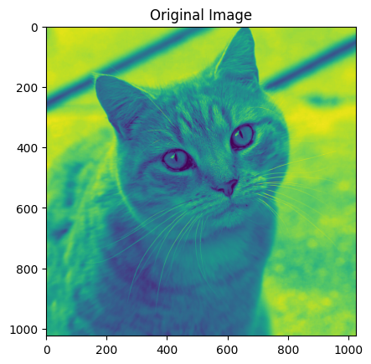 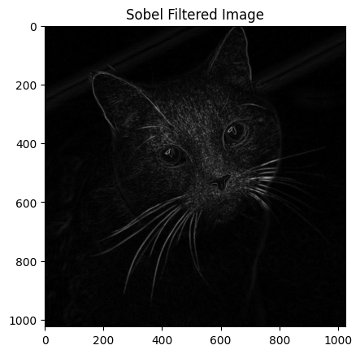

**Exercise-3**

**Objective:** Harris Corner Detection

**Code:**

1. import skimage as sk

2. import matplotlib.pyplot as plt

3. import numpy as np

4.

5. image = sk.io.imread('./image.png', sk.color.rgb2gray)

6. plt.imshow(image)

7. plt.title('Original Image')

8. plt.show()

9.

10. harris = sk.feature.corner_harris(image)

11. corners = sk.feature.corner_peaks(harris, min_distance=2, threshold_rel=0.02)

12.

13. corner_image = np.zeros_like(image)

14. corner_image[corners[:, 0], corners[:, 1]] = 1

15.

16. plt.imshow(corner_image, cmap='gray')

17. plt.title('Harris Corners')

18. plt.show()

**Ouput:**

 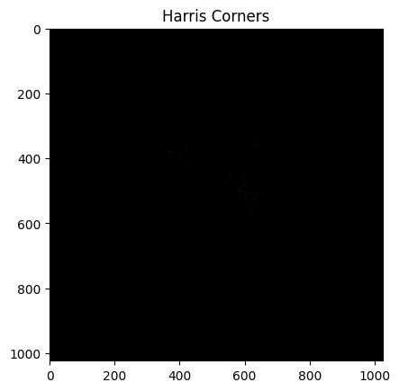

**Exercise-4**

**Objective:** 2D - Transformations on an image

**Code:**

1. import skimage as sk

2. import matplotlib.pyplot as plt

3. image = sk.io.imread("../image.png", as_gray=True)

4. plt.title("Original Image")

5. plt.imshow(image)



**1. Shear**

1. shear = sk.transform.warp(image,sk.transform.AffineTransform(shear=0.5))

2. plt.title("Sheared Image")

3. plt.imshow(shear)

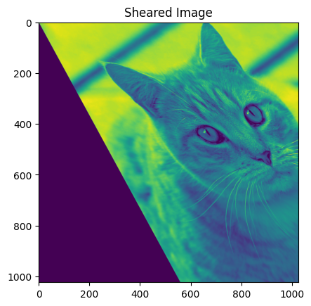

**2. Scale**

1. scaled = sk.transform.rescale(image, 0.5)

2. plt.title("Scaled Image")

3. plt.imshow(scaled)

4. plt.show()

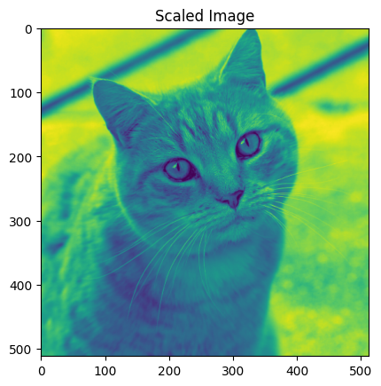

**3. Transition**

1. transition = sk.transform.warp(image, sk.transform.AffineTransform(translation=(100, 50)))

2. plt.title("Translated Image")

3. plt.imshow(transition)

4. plt.show()

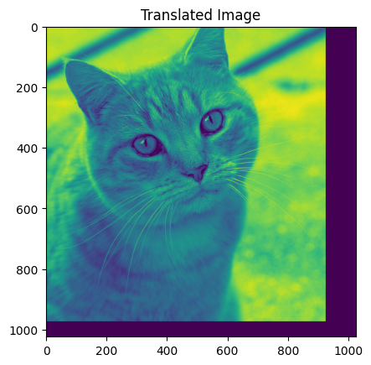

**4. Rotation**

1. rotated = sk.transform.rotate(image, 65)

2. plt.title("Rotated Image")

3. plt.imshow(rotated)

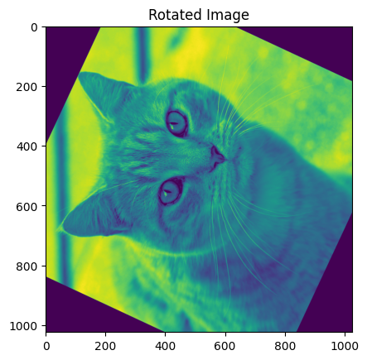

**5. Affine**

1. affined = sk.transform.warp(image, sk.transform.AffineTransform(translation=(1,2), shear=0.2))

2.

3. plt.figure(figsize=(5, 5))

4. plt.title("Affine Transformed Image")

5. plt.imshow(affined)

6. plt.show()

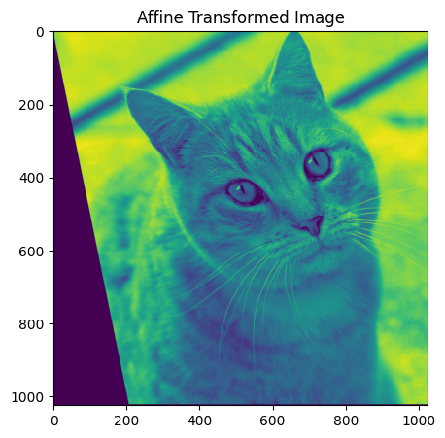

**Exercise-5**

**Objective:** Write a program to demonstrate Box Filter.

**Code:**

1. import cv2

2. import numpy as np

3. import matplotlib.pyplot as plt

4.

5. img = cv2.imread("../image.png", cv2.IMREAD_GRAYSCALE)

6.

7. # Apply box filter

8. box_filtered = cv2.boxFilter(img, ddepth=-1, ksize=(5, 5))

9.

10. # Display original and filtered images

11. plt.figure(figsize=(10, 5))

12. plt.subplot(1, 2, 1)

13. plt.title('Original')

14. plt.imshow(img, cmap='gray')

15.

16. plt.subplot(1, 2, 2)

17. plt.title('Box Filtered')

18. plt.imshow(box_filtered, cmap='gray')

19. plt.show()

**Output:**

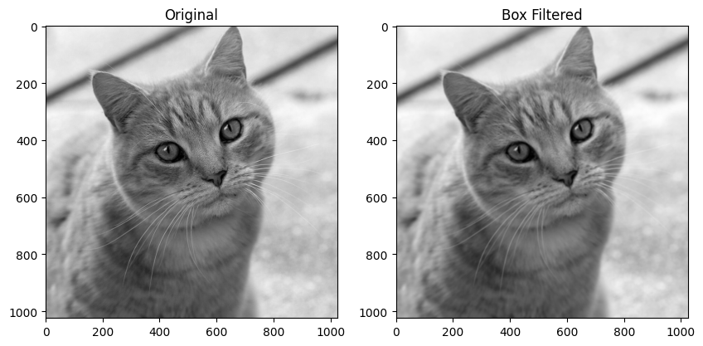

**Exercise-6**

**Objective:** Write a program to create a shadow effect on an image.

**Code:**

1. import cv2

2. import numpy as np

3. import matplotlib.pyplot as plt

4.

5. def shadow(image_path, shadow_offset=(10, 10), blur_ksize=(21, 21), shadow_color=(0, 0, 0, 10)):

6. # read the image with alpha channel

7. image = cv2.imread(image_path, cv2.IMREAD_UNCHANGED)

8. plt.title("Original Image")

9. plt.imshow(image)

10. plt.show()

11.

12. if image.shape[2] != 4:

13. raise ValueError("Image must have an alpha channel")

14.

15. h, w = image.shape[:2]

16.

17. # Create shadow base from alpha channel

18. alpha = image[:, :, 3]

19. shadow = np.zeros((h, w, 4), dtype=np.uint8)

20. shadow[:, :, :3] = shadow_color[:3]

21. shadow[:, :, 3] = alpha

22.

23. # Apply Gaussian blur to the shadow

24. blurred_shadow = cv2.GaussianBlur(shadow, blur_ksize, 0)

25.

26. # Create a larger canvas to accommodate the shadow offset

27. canvas_h = h + shadow_offset[1]

28. canvas_w = w + shadow_offset[0]

29. canvas = np.zeros((canvas_h, canvas_w, 4), dtype=np.uint8)

30.

31. # Print the blurred iamge

32. canvas[shadow_offset[1]:shadow_offset[1]+h, shadow_offset[0]:shadow_offset[0]+w] = blurred_shadow

33.

34. # Overlay original image onto the canvas

35. canvas[0:h, 0:w] = overlay_image_alpha(canvas[0:h, 0:w], image)

36.

37. return canvas

38.

39. def overlay_image_alpha(background, foreground):

40. alpha = foreground[:, :, 3] / 255.0

41. for c in range(3):

42. background[:, :, c] = (1 - alpha) * background[:, :, c] + alpha * foreground[:, :, c]

43. background[:, :, 3] = np.clip(foreground[:, :, 3] + background[:, :, 3] * (1 - alpha), 0, 255)

44. return background.astype(np.uint8)

45.

46.

47. result = shadow("../image1.png", shadow_offset=(10, 10), blur_ksize=(21, 21), shadow_color=(0, 0, 0, 10))

48. plt.title("Shadow Effect")

49. plt.imshow(result)

50. plt.show()

**Output:**

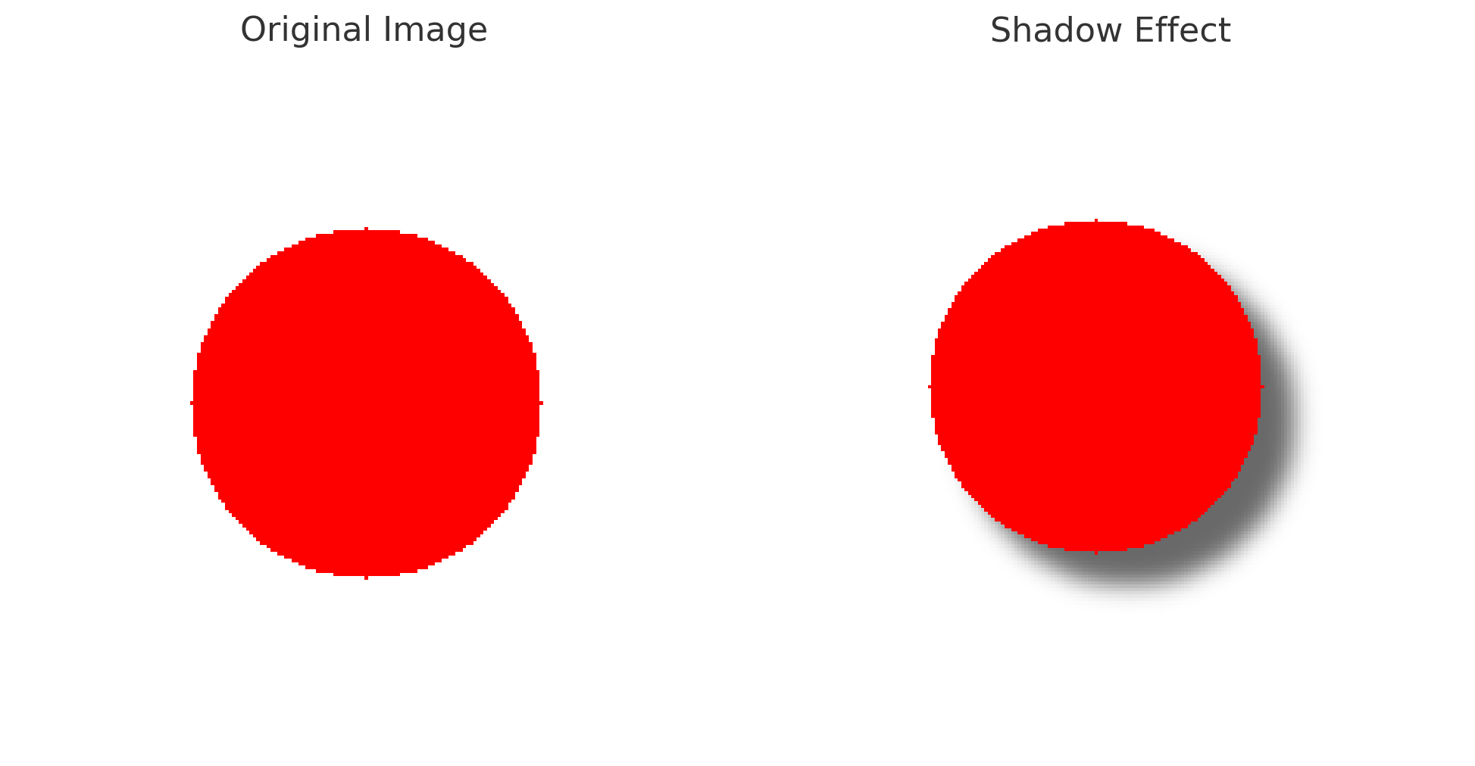

**Exercise-7**

**Objective:** Write a program to apply Gaussian Filtering to an image.

**Code:**

1. import cv2

2. import matplotlib.pyplot as plt

3.

4. img = '../image1.png'

5.

6. # Apply Gaussian filter

7. gaussian_filtered = cv2.GaussianBlur(img, ksize=(5, 5), sigmaX=0)

8.

9. # Display original and filtered images

10. plt.figure(figsize=(10, 5))

11. plt.subplot(1, 2, 1)

12. plt.title('Original')

13. plt.imshow(img, cmap='gray')

14.

15. plt.subplot(1, 2, 2)

16. plt.title('Gaussian Filtered')

17. plt.imshow(gaussian_filtered, cmap='gray')

18. plt.show()

**Output:**

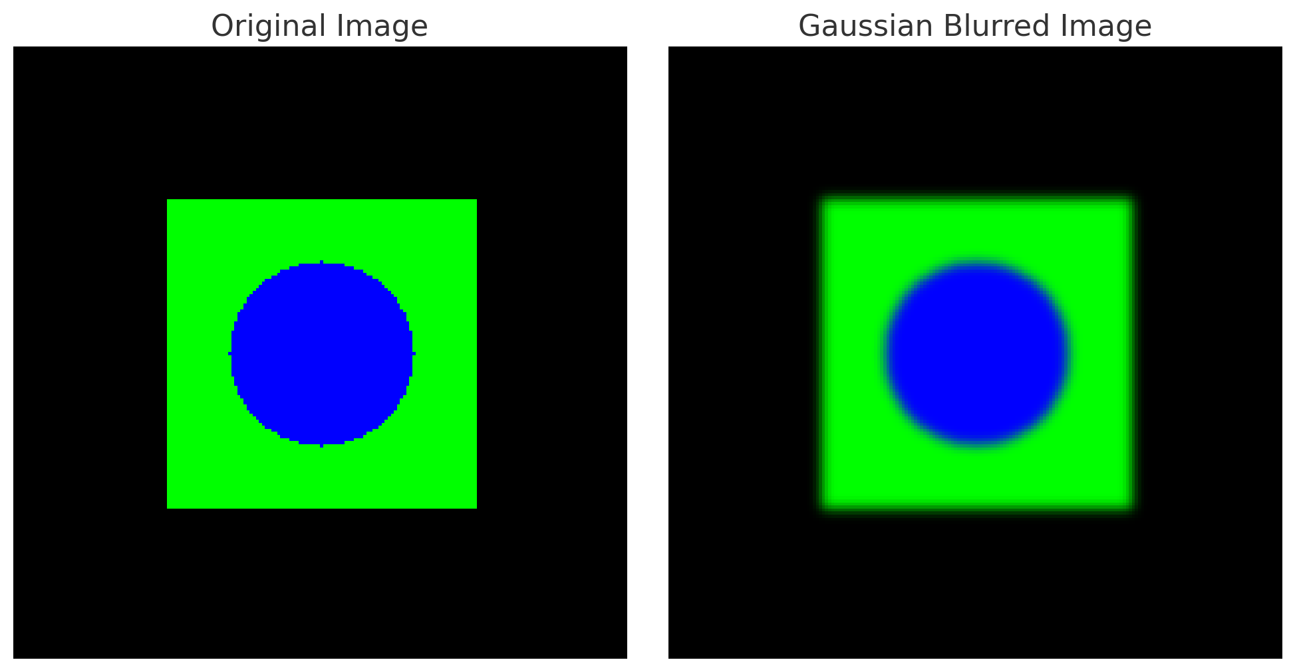

**Exercise-8**

**Objective:** Write a program to apply Laplacian Filtering to an image.

**Code:**

1. import cv2

2. import matplotlib.pyplot as plt

3.

4. img = '../image1.png'

5.

6. # Apply Laplacian filter

7. laplacian_filtered = cv2.Laplacian(img, ddepth=cv2.CV_64F)

8. # Display original and filtered images

9. plt.figure(figsize=(10, 5))

10. plt.subplot(1, 2, 1)

11. plt.title('Original')

12. plt.imshow(img, cmap='gray')

13. plt.subplot(1, 2, 2)

14. plt.title('Laplacian Filtered')

15. plt.imshow(laplacian_filtered, cmap='gray')

16. plt.show()

**Output:**

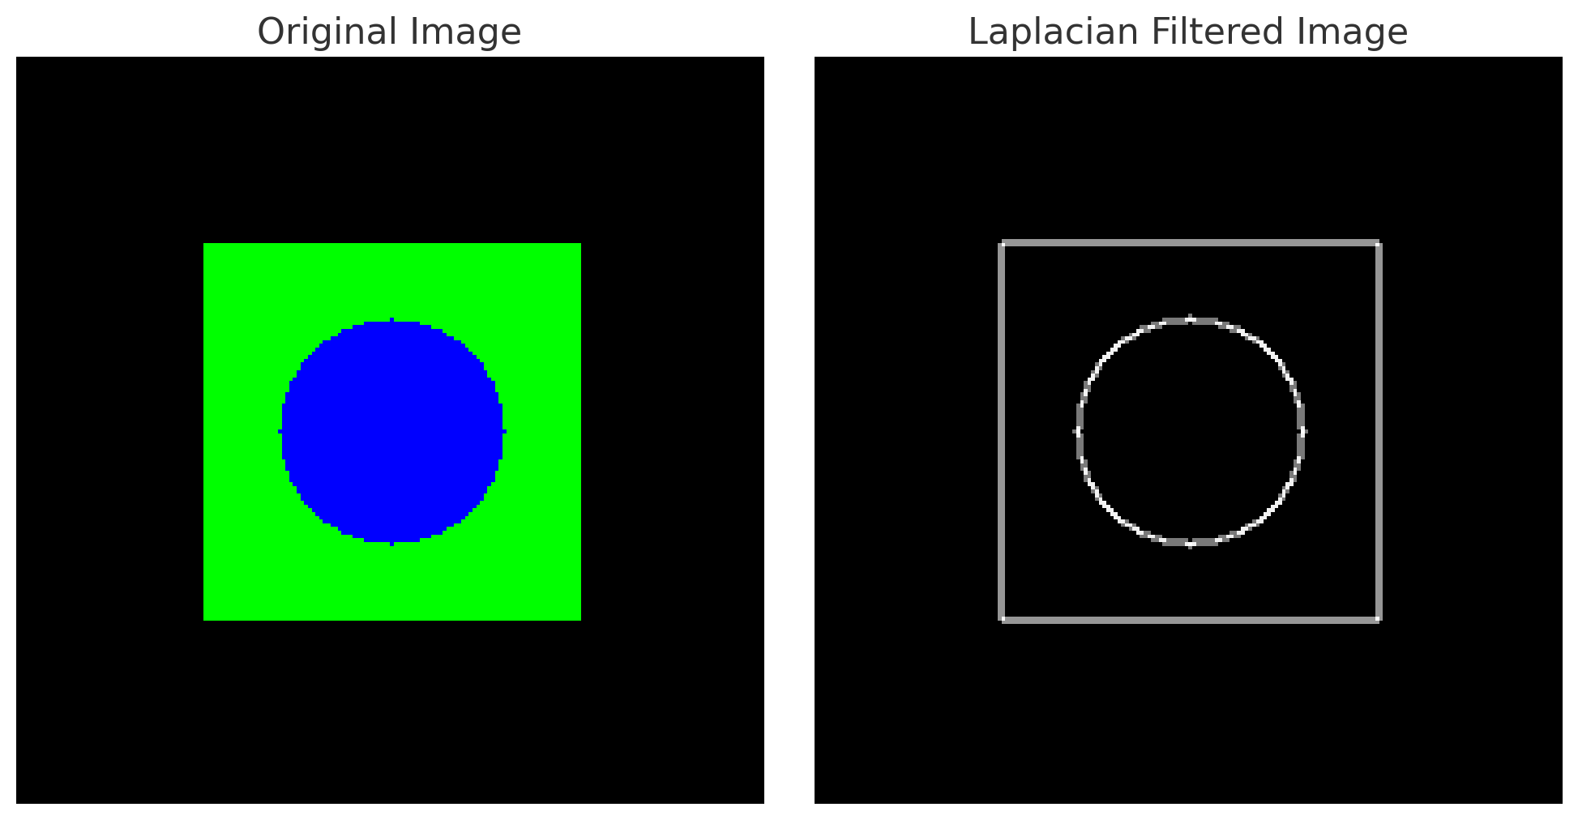

**Exercise-9**

**Objective:** Write a program to create a Gaussian Pyramid for an image.

**Code:**

1. import cv2

2. import numpy as np

3. import matplotlib.pyplot as plt

4.

5. def create_gaussian_pyramid(image, levels=3):

6. pyramid = [image]

7. for i in range(levels - 1):

8. # Apply Gaussian blur

9. blurred = cv2.GaussianBlur(pyramid[i], (5, 5), 1)

10. # Downsample the image

11. downsampled = cv2.pyrDown(blurred)

12. pyramid.append(downsampled)

13.

14. return pyramid

15.

16. image = cv2.imread("../image.png")

17. image_rgb = cv2.cvtColor(image, cv2.COLOR_BGR2RGB)

18.

19. # Create Gaussian Pyramid with 3 levels

20. pyramid = create_gaussian_pyramid(image_rgb, levels=3)

21.

22. # Plot the images in the pyramid

23. plt.figure(figsize=(15, 5))

24.

25. for i, img in enumerate(pyramid):

26. plt.subplot(1, len(pyramid), i + 1)

27. plt.title(f"Level {i + 1}")

28. plt.imshow(img)

29. plt.tight_layout()

30. plt.show()

**Output:**

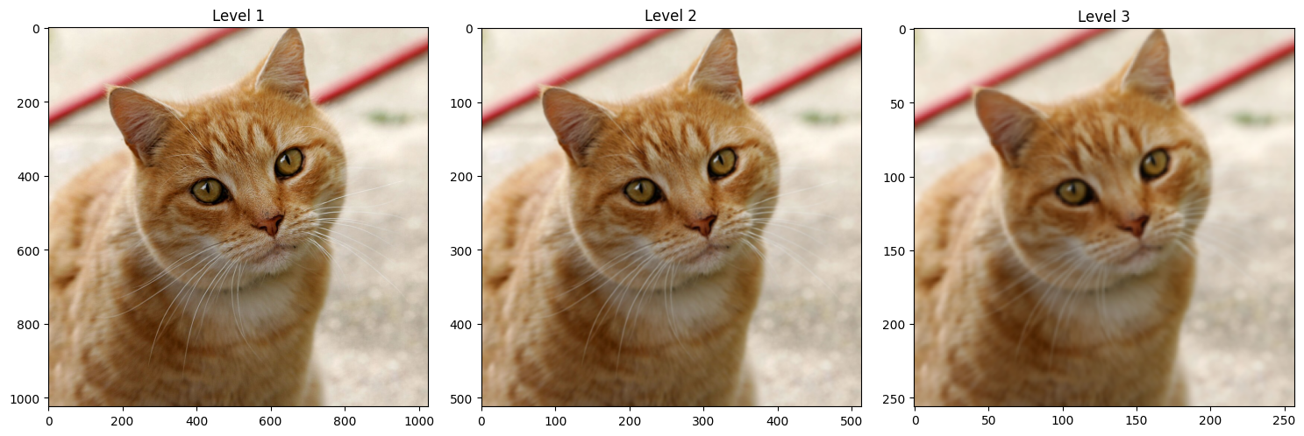

**Exercise-10**

**Objective**: Multiclass Image Classification using CNN.

**Code:**

# IMPORTANT: RUN THIS CELL IN ORDER TO IMPORT YOUR KAGGLE DATA SOURCES,  
# THEN FEEL FREE TO DELETE THIS CELL.  
  
import kagglehub  
path = kagglehub.dataset_download('puneet6060/intel-image-classification')  
  
print('Data source import complete.')  
print("Path:", path)

### **1. Import the Required Libraries**

import numpy as np  
import matplotlib.pyplot as plt  
import seaborn as sns  
%matplotlib inline  
  
import cv2  
import os  
os.environ["TF_CPP_MIN_LOG_LEVEL"] = "2"  
import warnings  
warnings.filterwarnings('ignore')  
  
from sklearn.metrics import confusion_matrix, classification_report  
  
import tensorflow as tf  
from tensorflow.keras.models import Sequential  
from tensorflow.keras.layers import Activation, BatchNormalization, Conv2D, Dense, Dropout, Flatten, MaxPooling2D  
from tensorflow.keras.preprocessing.image import ImageDataGenerator  
from tensorflow.keras.optimizers import Adam  
from tensorflow.keras.losses import CategoricalCrossentropy  
from tensorflow.keras.regularizers import l2  
from tensorflow.keras.callbacks import ReduceLROnPlateau

### **2. Load the Image Training and Validation Datasets**

#### **i. Get the Image Dataset Paths**

train_dataset_path = path + '/seg_train/seg_train/'  
validation_dataset_path = path + '/seg_test/seg_test/'

#### **ii. Load Image Datasets and Apply Augmentations**

Since the images present in the datasets are 150x150px in size, the image height and width are taken as 150, 150 respectively. The batch size value can be changed if required.

IMG_WIDTH = 150  
IMG_HEIGHT = 150  
BATCH_SIZE = 32

Loading the training dataset and applying augmentations on it.

train_datagen = ImageDataGenerator(rescale=1.0/255,  
 zoom_range=0.2,  
 width_shift_range=0.2,  
 height_shift_range=0.2,  
 fill_mode='nearest')  
train_generator = train_datagen.flow_from_directory(train_dataset_path,  
 target_size=(IMG_WIDTH, IMG_HEIGHT),  
 batch_size=BATCH_SIZE,  
 class_mode='categorical',  
 shuffle=True)

Found 14034 images belonging to 6 classes.

Loading the validation dataset.

validation_datagen = ImageDataGenerator(rescale=1.0/255)  
validation_generator = validation_datagen.flow_from_directory(validation_dataset_path,  
 target_size=(IMG_WIDTH, IMG_HEIGHT),  
 batch_size=BATCH_SIZE,  
 class_mode='categorical',  
 shuffle=True)

Found 3000 images belonging to 6 classes.

#### **iii. Get the Label Mappings**

The labels dictionary is made in order to retrive the class names against the label indices used for training the model

labels = {value: key for key, value in train_generator.class_indices.items()}  
  
print("Label Mappings for classes present in the training and validation datasets\n")  
for key, value in labels.items():  
 print(f"{key} : {value}")

Label Mappings for classes present in the training and validation datasets  
  
0 : buildings  
1 : forest  
2 : glacier  
3 : mountain  
4 : sea  
5 : street

### **3. Plotting Sample Training Images**

fig, ax = plt.subplots(nrows=2, ncols=5, figsize=(15, 12))  
idx = 0  
  
for i in range(2):  
 for j in range(5):  
 label = labels[np.argmax(train_generator[0][1][idx])]  
 ax[i, j].set_title(f"{label}")  
 ax[i, j].imshow(train_generator[0][0][idx][:, :, :])  
 ax[i, j].axis("off")  
 idx += 1  
  
plt.tight_layout()  
plt.suptitle("Sample Training Images", fontsize=21)  
plt.show()

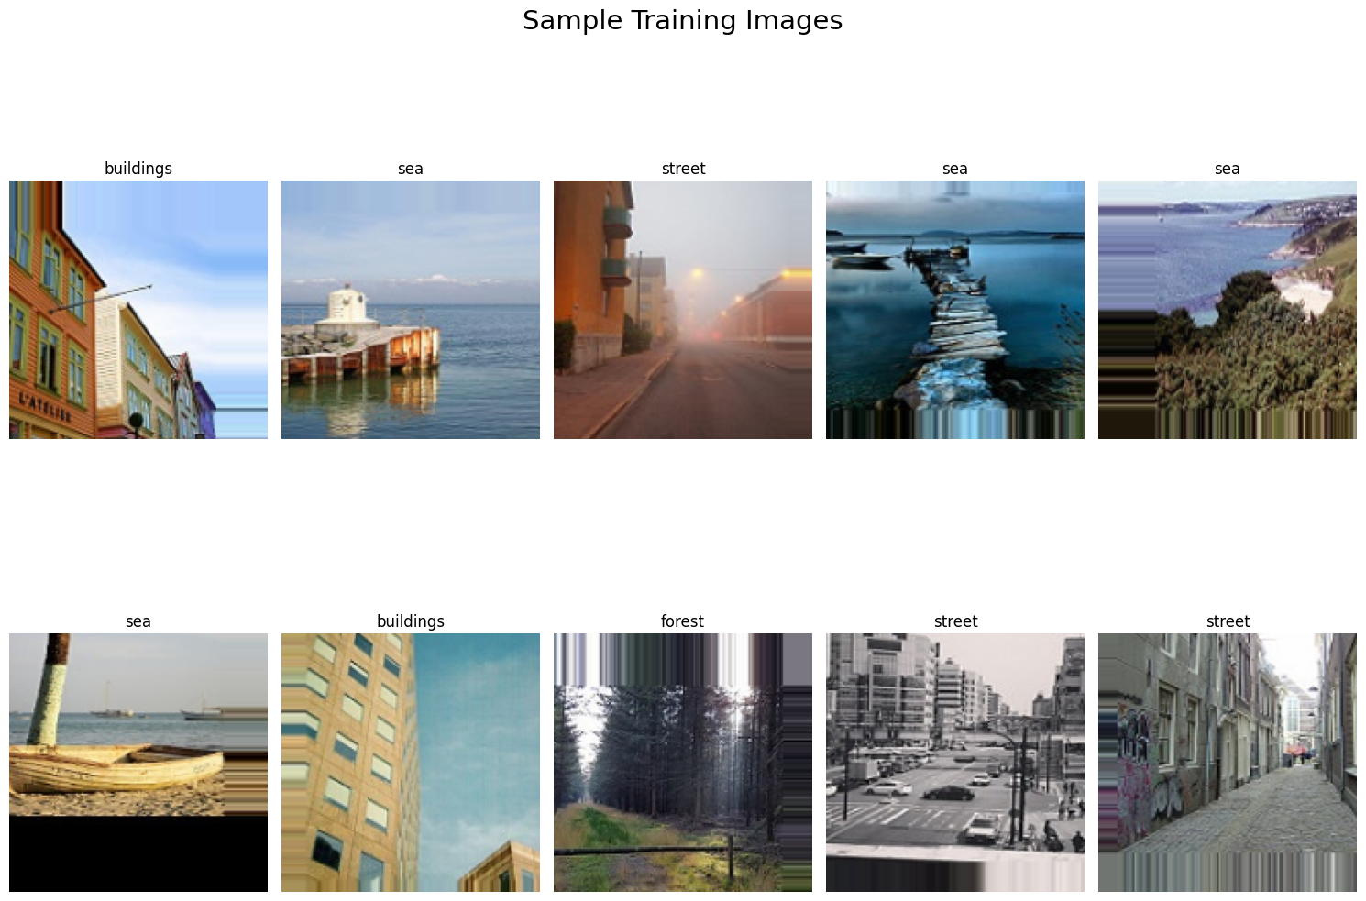

### **4. Training a CNN Model**

Since the training dataset is ready let's create a simple CNN Model to train on the image datasets

#### **i. Create a CNN Model**

def create_model():  
 model = Sequential([  
 Conv2D(filters=128, kernel_size=(5, 5), padding='valid', input_shape=(IMG_WIDTH, IMG_HEIGHT, 3)),  
 Activation('relu'),  
 MaxPooling2D(pool_size=(2, 2)),  
 BatchNormalization(),  
  
 Conv2D(filters=64, kernel_size=(3, 3), padding='valid', kernel_regularizer=l2(0.00005)),  
 Activation('relu'),  
 MaxPooling2D(pool_size=(2, 2)),  
 BatchNormalization(),  
  
 Conv2D(filters=32, kernel_size=(3, 3), padding='valid', kernel_regularizer=l2(0.00005)),  
 Activation('relu'),  
 MaxPooling2D(pool_size=(2, 2)),  
 BatchNormalization(),  
  
 Flatten(),  
  
 Dense(units=256, activation='relu'),  
 Dropout(0.5),  
 Dense(units=6, activation='softmax')  
 ])  
  
 return model

cnn_model = create_model()

print(cnn_model.summary())

Model: "sequential_1"

┏━━━━━━━━━━━━━━━━━━━━━━━━━━━━━━━━━┳━━━━━━━━━━━━━━━━━━━━━━━━┳━━━━━━━━━━━━━━━┓  
┃ Layer (type) ┃ Output Shape ┃ Param # ┃  
┡━━━━━━━━━━━━━━━━━━━━━━━━━━━━━━━━━╇━━━━━━━━━━━━━━━━━━━━━━━━╇━━━━━━━━━━━━━━━┩  
│ conv2d_3 (Conv2D) │ (None, 146, 146, 128) │ 9,728 │  
├─────────────────────────────────┼────────────────────────┼───────────────┤  
│ activation_3 (Activation) │ (None, 146, 146, 128) │ 0 │  
├─────────────────────────────────┼────────────────────────┼───────────────┤  
│ max_pooling2d_3 (MaxPooling2D) │ (None, 73, 73, 128) │ 0 │  
├─────────────────────────────────┼────────────────────────┼───────────────┤  
│ batch_normalization_3 │ (None, 73, 73, 128) │ 512 │  
│ (BatchNormalization) │ │ │  
├─────────────────────────────────┼────────────────────────┼───────────────┤  
│ conv2d_4 (Conv2D) │ (None, 71, 71, 64) │ 73,792 │  
├─────────────────────────────────┼────────────────────────┼───────────────┤  
│ activation_4 (Activation) │ (None, 71, 71, 64) │ 0 │  
├─────────────────────────────────┼────────────────────────┼───────────────┤  
│ max_pooling2d_4 (MaxPooling2D) │ (None, 35, 35, 64) │ 0 │  
├─────────────────────────────────┼────────────────────────┼───────────────┤  
│ batch_normalization_4 │ (None, 35, 35, 64) │ 256 │  
│ (BatchNormalization) │ │ │  
├─────────────────────────────────┼────────────────────────┼───────────────┤  
│ conv2d_5 (Conv2D) │ (None, 33, 33, 32) │ 18,464 │  
├─────────────────────────────────┼────────────────────────┼───────────────┤  
│ activation_5 (Activation) │ (None, 33, 33, 32) │ 0 │  
├─────────────────────────────────┼────────────────────────┼───────────────┤  
│ max_pooling2d_5 (MaxPooling2D) │ (None, 16, 16, 32) │ 0 │  
├─────────────────────────────────┼────────────────────────┼───────────────┤  
│ batch_normalization_5 │ (None, 16, 16, 32) │ 128 │  
│ (BatchNormalization) │ │ │  
├─────────────────────────────────┼────────────────────────┼───────────────┤  
│ flatten_1 (Flatten) │ (None, 8192) │ 0 │  
├─────────────────────────────────┼────────────────────────┼───────────────┤  
│ dense_2 (Dense) │ (None, 256) │ 2,097,408 │  
├─────────────────────────────────┼────────────────────────┼───────────────┤  
│ dropout_1 (Dropout) │ (None, 256) │ 0 │  
├─────────────────────────────────┼────────────────────────┼───────────────┤  
│ dense_3 (Dense) │ (None, 6) │ 1,542 │  
└─────────────────────────────────┴────────────────────────┴───────────────┘

Total params: 2,201,830 (8.40 MB)

Trainable params: 2,201,382 (8.40 MB)

Non-trainable params: 448 (1.75 KB)

None

#### **ii. Defining Callbacks**

A callback is an object that can perform actions at various stages of training (e.g. at the start or end of an epoch, before or after a single batch, etc)

#### **a. Reduce Learning Rate on Plateau**

Is used to reduce the learning rate when a metric has stopped improving.

reduce_lr = ReduceLROnPlateau(monitor='val_loss', factor=np.sqrt(0.1), patience=5, verbose=1)

#### **iii. Defining the Optimizer**

optimizer = Adam(learning_rate=0.001)

#### **iv. Compile the Model**

cnn_model.compile(optimizer=optimizer, loss=CategoricalCrossentropy(), metrics=['accuracy'])

#### **v. Training the Model**

history = cnn_model.fit(train_generator, epochs=50, validation_data=validation_generator,  
 verbose=2,  
 callbacks=[reduce_lr])

Epoch 1/50  
439/439 - 65s - 149ms/step - accuracy: 0.4964 - loss: 2.1109 - val_accuracy: 0.5127 - val_loss: 1.1990 - learning_rate: 1.0000e-03  
Epoch 2/50  
439/439 - 48s - 110ms/step - accuracy: 0.6131 - loss: 1.0702 - val_accuracy: 0.5640 - val_loss: 1.3726 - learning_rate: 1.0000e-03  
Epoch 3/50  
439/439 - 48s - 110ms/step - accuracy: 0.6568 - loss: 0.9232 - val_accuracy: 0.6773 - val_loss: 0.9458 - learning_rate: 1.0000e-03  
Epoch 4/50  
439/439 - 49s - 111ms/step - accuracy: 0.6912 - loss: 0.8486 - val_accuracy: 0.7130 - val_loss: 0.8210 - learning_rate: 1.0000e-03  
Epoch 5/50  
439/439 - 48s - 109ms/step - accuracy: 0.7116 - loss: 0.8024 - val_accuracy: 0.7020 - val_loss: 0.7868 - learning_rate: 1.0000e-03  
Epoch 6/50  
439/439 - 48s - 109ms/step - accuracy: 0.7282 - loss: 0.7564 - val_accuracy: 0.7470 - val_loss: 0.7527 - learning_rate: 1.0000e-03  
Epoch 7/50  
439/439 - 48s - 110ms/step - accuracy: 0.7437 - loss: 0.7180 - val_accuracy: 0.8000 - val_loss: 0.5946 - learning_rate: 1.0000e-03  
Epoch 8/50  
439/439 - 48s - 110ms/step - accuracy: 0.7542 - loss: 0.6940 - val_accuracy: 0.7750 - val_loss: 0.6176 - learning_rate: 1.0000e-03  
Epoch 9/50  
439/439 - 48s - 110ms/step - accuracy: 0.7666 - loss: 0.6668 - val_accuracy: 0.3233 - val_loss: 6.4530 - learning_rate: 1.0000e-03  
Epoch 10/50  
439/439 - 48s - 110ms/step - accuracy: 0.7772 - loss: 0.6363 - val_accuracy: 0.8157 - val_loss: 0.5311 - learning_rate: 1.0000e-03  
Epoch 11/50  
439/439 - 48s - 110ms/step - accuracy: 0.7830 - loss: 0.6219 - val_accuracy: 0.7837 - val_loss: 0.6171 - learning_rate: 1.0000e-03  
Epoch 12/50  
439/439 - 48s - 109ms/step - accuracy: 0.7861 - loss: 0.6130 - val_accuracy: 0.7420 - val_loss: 0.7246 - learning_rate: 1.0000e-03  
Epoch 13/50  
439/439 - 48s - 109ms/step - accuracy: 0.7909 - loss: 0.5946 - val_accuracy: 0.6197 - val_loss: 1.1284 - learning_rate: 1.0000e-03  
Epoch 14/50  
439/439 - 48s - 110ms/step - accuracy: 0.7971 - loss: 0.5837 - val_accuracy: 0.8090 - val_loss: 0.5444 - learning_rate: 1.0000e-03  
Epoch 15/50  
  
Epoch 15: ReduceLROnPlateau reducing learning rate to 0.00031622778103685084.  
439/439 - 48s - 110ms/step - accuracy: 0.8096 - loss: 0.5662 - val_accuracy: 0.7547 - val_loss: 0.7665 - learning_rate: 1.0000e-03  
Epoch 16/50  
439/439 - 49s - 112ms/step - accuracy: 0.8318 - loss: 0.4980 - val_accuracy: 0.8703 - val_loss: 0.3983 - learning_rate: 3.1623e-04  
Epoch 17/50  
439/439 - 48s - 109ms/step - accuracy: 0.8394 - loss: 0.4691 - val_accuracy: 0.8630 - val_loss: 0.4069 - learning_rate: 3.1623e-04  
Epoch 18/50  
439/439 - 48s - 110ms/step - accuracy: 0.8464 - loss: 0.4613 - val_accuracy: 0.8727 - val_loss: 0.3951 - learning_rate: 3.1623e-04  
Epoch 19/50  
439/439 - 48s - 110ms/step - accuracy: 0.8440 - loss: 0.4555 - val_accuracy: 0.8333 - val_loss: 0.5072 - learning_rate: 3.1623e-04  
Epoch 20/50  
439/439 - 48s - 110ms/step - accuracy: 0.8454 - loss: 0.4509 - val_accuracy: 0.8790 - val_loss: 0.3827 - learning_rate: 3.1623e-04  
Epoch 21/50  
439/439 - 48s - 109ms/step - accuracy: 0.8499 - loss: 0.4347 - val_accuracy: 0.8083 - val_loss: 0.6546 - learning_rate: 3.1623e-04  
Epoch 22/50  
439/439 - 48s - 110ms/step - accuracy: 0.8572 - loss: 0.4179 - val_accuracy: 0.8757 - val_loss: 0.4188 - learning_rate: 3.1623e-04  
Epoch 23/50  
439/439 - 48s - 110ms/step - accuracy: 0.8546 - loss: 0.4227 - val_accuracy: 0.8743 - val_loss: 0.4059 - learning_rate: 3.1623e-04  
Epoch 24/50  
439/439 - 49s - 111ms/step - accuracy: 0.8556 - loss: 0.4202 - val_accuracy: 0.8563 - val_loss: 0.4641 - learning_rate: 3.1623e-04  
Epoch 25/50  
439/439 - 48s - 110ms/step - accuracy: 0.8575 - loss: 0.4151 - val_accuracy: 0.8737 - val_loss: 0.3679 - learning_rate: 3.1623e-04  
Epoch 26/50  
439/439 - 48s - 110ms/step - accuracy: 0.8588 - loss: 0.4144 - val_accuracy: 0.8707 - val_loss: 0.3899 - learning_rate: 3.1623e-04  
Epoch 27/50  
439/439 - 48s - 109ms/step - accuracy: 0.8598 - loss: 0.4095 - val_accuracy: 0.8860 - val_loss: 0.3508 - learning_rate: 3.1623e-04  
Epoch 28/50  
439/439 - 49s - 111ms/step - accuracy: 0.8655 - loss: 0.4053 - val_accuracy: 0.8560 - val_loss: 0.4347 - learning_rate: 3.1623e-04  
Epoch 29/50  
439/439 - 48s - 109ms/step - accuracy: 0.8625 - loss: 0.3991 - val_accuracy: 0.8303 - val_loss: 0.5277 - learning_rate: 3.1623e-04  
Epoch 30/50  
439/439 - 48s - 109ms/step - accuracy: 0.8647 - loss: 0.3964 - val_accuracy: 0.8847 - val_loss: 0.3669 - learning_rate: 3.1623e-04  
Epoch 31/50  
439/439 - 48s - 108ms/step - accuracy: 0.8645 - loss: 0.3888 - val_accuracy: 0.8660 - val_loss: 0.4414 - learning_rate: 3.1623e-04  
Epoch 32/50  
  
Epoch 32: ReduceLROnPlateau reducing learning rate to 0.00010000000639606199.  
439/439 - 47s - 108ms/step - accuracy: 0.8720 - loss: 0.3785 - val_accuracy: 0.8730 - val_loss: 0.4176 - learning_rate: 3.1623e-04  
Epoch 33/50  
439/439 - 48s - 109ms/step - accuracy: 0.8777 - loss: 0.3583 - val_accuracy: 0.8903 - val_loss: 0.3283 - learning_rate: 1.0000e-04  
Epoch 34/50  
439/439 - 48s - 109ms/step - accuracy: 0.8813 - loss: 0.3551 - val_accuracy: 0.8913 - val_loss: 0.3452 - learning_rate: 1.0000e-04  
Epoch 35/50  
439/439 - 47s - 108ms/step - accuracy: 0.8802 - loss: 0.3503 - val_accuracy: 0.8847 - val_loss: 0.3761 - learning_rate: 1.0000e-04  
Epoch 36/50  
439/439 - 47s - 107ms/step - accuracy: 0.8833 - loss: 0.3446 - val_accuracy: 0.8840 - val_loss: 0.3650 - learning_rate: 1.0000e-04  
Epoch 37/50  
439/439 - 47s - 107ms/step - accuracy: 0.8816 - loss: 0.3385 - val_accuracy: 0.8917 - val_loss: 0.3435 - learning_rate: 1.0000e-04  
Epoch 38/50  
  
Epoch 38: ReduceLROnPlateau reducing learning rate to 3.1622778103685084e-05.  
439/439 - 48s - 108ms/step - accuracy: 0.8842 - loss: 0.3398 - val_accuracy: 0.8650 - val_loss: 0.4605 - learning_rate: 1.0000e-04  
Epoch 39/50  
439/439 - 47s - 108ms/step - accuracy: 0.8845 - loss: 0.3349 - val_accuracy: 0.8853 - val_loss: 0.3488 - learning_rate: 3.1623e-05  
Epoch 40/50  
439/439 - 47s - 108ms/step - accuracy: 0.8854 - loss: 0.3262 - val_accuracy: 0.8820 - val_loss: 0.3739 - learning_rate: 3.1623e-05  
Epoch 41/50  
439/439 - 47s - 108ms/step - accuracy: 0.8901 - loss: 0.3225 - val_accuracy: 0.8920 - val_loss: 0.3374 - learning_rate: 3.1623e-05  
Epoch 42/50  
439/439 - 48s - 108ms/step - accuracy: 0.8901 - loss: 0.3231 - val_accuracy: 0.8940 - val_loss: 0.3280 - learning_rate: 3.1623e-05  
Epoch 43/50  
439/439 - 47s - 107ms/step - accuracy: 0.8890 - loss: 0.3229 - val_accuracy: 0.8933 - val_loss: 0.3381 - learning_rate: 3.1623e-05  
Epoch 44/50  
439/439 - 48s - 109ms/step - accuracy: 0.8868 - loss: 0.3286 - val_accuracy: 0.8920 - val_loss: 0.3412 - learning_rate: 3.1623e-05  
Epoch 45/50  
439/439 - 48s - 108ms/step - accuracy: 0.8896 - loss: 0.3338 - val_accuracy: 0.8943 - val_loss: 0.3311 - learning_rate: 3.1623e-05  
Epoch 46/50  
439/439 - 48s - 109ms/step - accuracy: 0.8891 - loss: 0.3221 - val_accuracy: 0.8930 - val_loss: 0.3368 - learning_rate: 3.1623e-05  
Epoch 47/50  
  
Epoch 47: ReduceLROnPlateau reducing learning rate to 1.0000000409520217e-05.  
439/439 - 48s - 109ms/step - accuracy: 0.8886 - loss: 0.3198 - val_accuracy: 0.8903 - val_loss: 0.3477 - learning_rate: 3.1623e-05  
Epoch 48/50  
439/439 - 48s - 110ms/step - accuracy: 0.8898 - loss: 0.3246 - val_accuracy: 0.8947 - val_loss: 0.3303 - learning_rate: 1.0000e-05  
Epoch 49/50  
439/439 - 47s - 108ms/step - accuracy: 0.8882 - loss: 0.3241 - val_accuracy: 0.8953 - val_loss: 0.3321 - learning_rate: 1.0000e-05  
Epoch 50/50  
439/439 - 48s - 108ms/step - accuracy: 0.8893 - loss: 0.3253 - val_accuracy: 0.8933 - val_loss: 0.3319 - learning_rate: 1.0000e-05

### **5. Plotting the Model Metrics**

#### **i. Plotting training and validation accuracy, loss and learning rate**

train_accuracy = history.history['accuracy']  
val_accuracy = history.history['val_accuracy']  
  
train_loss = history.history['loss']  
val_loss = history.history['val_loss']  
  
learning_rate = history.history['learning_rate']

fig, ax = plt.subplots(nrows=3, ncols=1, figsize=(12, 10))  
  
ax[0].set_title('Training Accuracy vs. Epochs')  
ax[0].plot(train_accuracy, 'o-', label='Train Accuracy')  
ax[0].plot(val_accuracy, 'o-', label='Validation Accuracy')  
ax[0].set_xlabel('Epochs')  
ax[0].set_ylabel('Accuracy')  
ax[0].legend(loc='best')  
  
ax[1].set_title('Training/Validation Loss vs. Epochs')  
ax[1].plot(train_loss, 'o-', label='Train Loss')  
ax[1].plot(val_loss, 'o-', label='Validation Loss')  
ax[1].set_xlabel('Epochs')  
ax[1].set_ylabel('Loss')  
ax[1].legend(loc='best')  
  
ax[2].set_title('Learning Rate vs. Epochs')  
ax[2].plot(learning_rate, 'o-', label='Learning Rate')  
ax[2].set_xlabel('Epochs')  
ax[2].set_ylabel('Loss')  
ax[2].legend(loc='best')  
  
plt.tight_layout()  
plt.show()

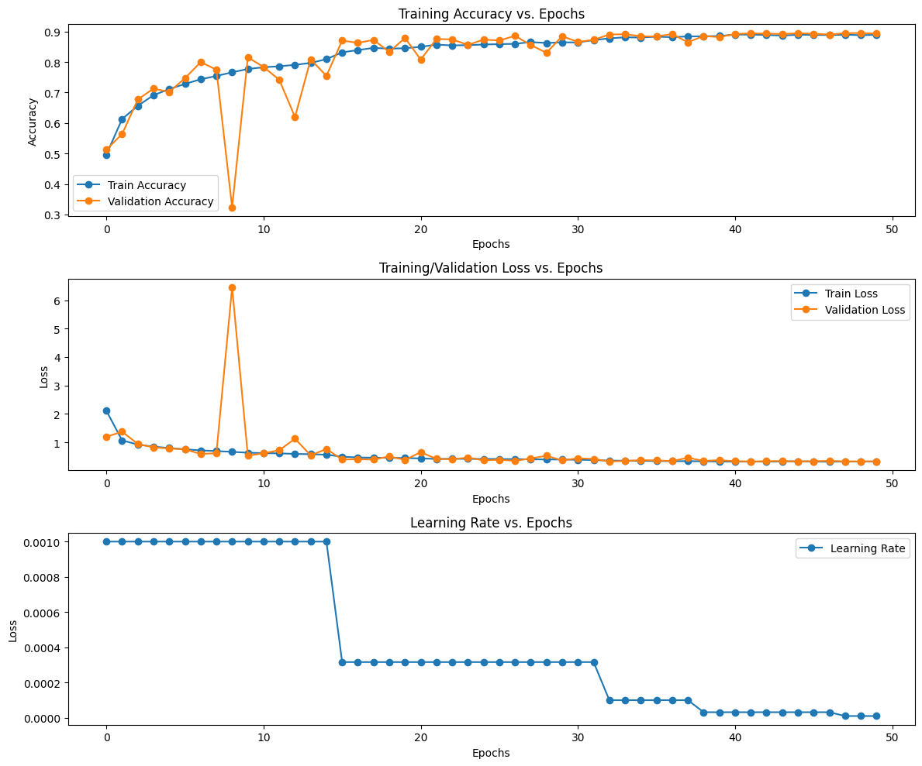

### **6. Testing the Model on Test Set**

Testing the model on the validation dataset because a seperate dataset for testing is not available.

test_dataset = path + '/seg_test/seg_test/'

test_datagen = ImageDataGenerator(rescale=1.0/255)  
  
test_generator = test_datagen.flow_from_directory(test_dataset,  
 shuffle=False,  
 batch_size=BATCH_SIZE,  
 target_size = (IMG_WIDTH, IMG_HEIGHT),  
 class_mode='categorical')

Found 3000 images belonging to 6 classes.

### **7. Model Prediction on the Test Dataset**

predictions = cnn_model.predict(test_generator)

94/94 ━━━━━━━━━━━━━━━━━━━━ 4s 30ms/step

fig, ax = plt.subplots(nrows=2, ncols=5, figsize=(12, 10))  
idx = 0  
  
for i in range(2):  
 for j in range(5):  
 predicted_label = labels[np.argmax(predictions[idx])]  
 ax[i, j].set_title(f"{predicted_label}")  
 ax[i, j].imshow(test_generator[0][0][idx])  
 ax[i, j].axis("off")  
 idx += 1  
  
plt.tight_layout()  
plt.suptitle("Test Dataset Predictions", fontsize=20)  
plt.show()

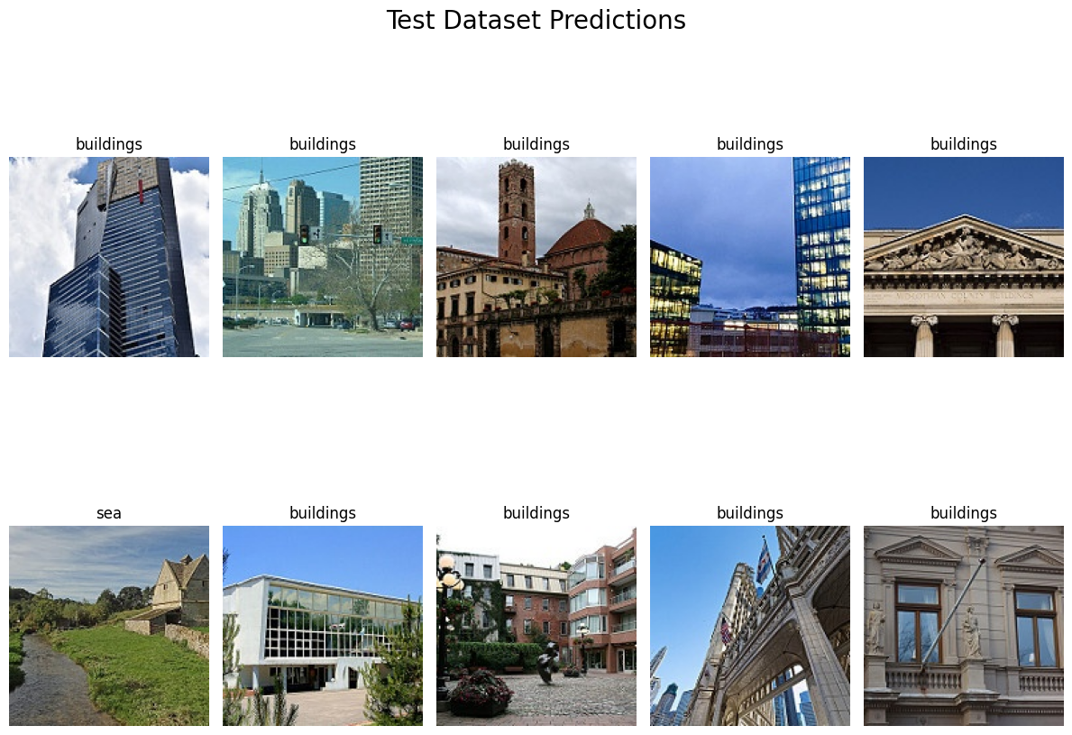

test_loss, test_accuracy = cnn_model.evaluate(test_generator, batch_size=BATCH_SIZE)

94/94 ━━━━━━━━━━━━━━━━━━━━ 2s 19ms/step - accuracy: 0.9104 - loss: 0.2821

print(f"Test Loss: {test_loss}")  
print(f"Test Accuracy: {test_accuracy}")

Test Loss: 0.3318774402141571  
Test Accuracy: 0.8933333158493042

The test loss and test accuracy is the same as validation loss and validation accuracy at the last step since the testing and validation datasets are same.

### **8. Plotting the Classification Metrics**

### **i. Confusion Matrix**

y_pred = np.argmax(predictions, axis=1)  
y_true = test_generator.classes

cf_mtx = confusion_matrix(y_true, y_pred)  
  
group_counts = ["{0:0.0f}".format(value) for value in cf_mtx.flatten()]  
group_percentages = ["{0:.2%}".format(value) for value in cf_mtx.flatten()/np.sum(cf_mtx)]  
box_labels = [f"{v1}\n({v2})" for v1, v2 in zip(group_counts, group_percentages)]  
box_labels = np.asarray(box_labels).reshape(6, 6)  
  
plt.figure(figsize = (12, 10))  
sns.heatmap(cf_mtx, xticklabels=labels.values(), yticklabels=labels.values(),  
 cmap="YlGnBu", fmt="", annot=box_labels)  
plt.xlabel('Predicted Classes')  
plt.ylabel('True Classes')  
plt.show()

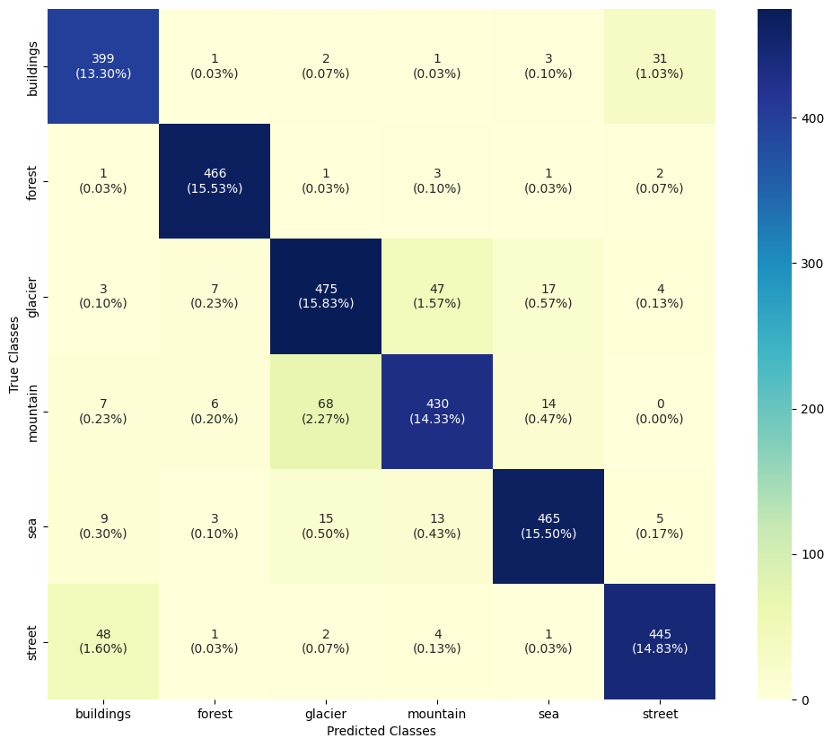

print(classification_report(y_true, y_pred, target_names=labels.values()))

precision recall f1-score support  
  
 buildings 0.85 0.91 0.88 437  
 forest 0.96 0.98 0.97 474  
 glacier 0.84 0.86 0.85 553  
 mountain 0.86 0.82 0.84 525  
 sea 0.93 0.91 0.92 510  
 street 0.91 0.89 0.90 501  
  
 accuracy 0.89 3000  
 macro avg 0.89 0.90 0.89 3000  
weighted avg 0.89 0.89 0.89 3000

### **9. Wrong Predictions**

Let's see where the model has given wrong predictions and what were the actual predictions on those images.

errors = (y_true - y_pred != 0)  
y_true_errors = y_true[errors]  
y_pred_errors = y_pred[errors]

test_images = test_generator.filenames  
test_img = np.asarray(test_images)[errors]

fig, ax = plt.subplots(nrows=2, ncols=5, figsize=(12, 10))  
idx = 0  
  
for i in range(2):  
 for j in range(5):  
 idx = np.random.randint(0, len(test_img))  
 true_index = y_true_errors[idx]  
 true_label = labels[true_index]  
 predicted_index = y_pred_errors[idx]  
 predicted_label = labels[predicted_index]  
 ax[i, j].set_title(f"True Label: {true_label} \n Predicted Label: {predicted_label}")  
 img_path = os.path.join(test_dataset, test_img[idx])  
 img = cv2.imread(img_path)  
 img = cv2.cvtColor(img, cv2.COLOR_BGR2RGB)  
 ax[i, j].imshow(img)  
 ax[i, j].axis("off")  
  
plt.tight_layout()  
plt.suptitle('Wrong Predictions made on test set', fontsize=20)  
plt.show()

